INSTRUCTOR-ONLY COMPLETED-PROJECT KEY

Introduction to Drone Remote Sensing
  - Completed Marshview Wetland Investigation and Capstone Model
Purpose of this key
Use this model to calibrate scoring, show the expected depth of reasoning after students submit, and identify acceptable evidence-based variations. It is not intended as a script students must copy.

At a glance
Client and site | Marshview Wetland Preserve (simulated learning site)
Platform | DJI Mavic 3 Multispectral
Demonstration flight | 200 ft AGL (61 m), nadir mapping grid
Products | Natural-color orthomosaic, NDVI surface, field-sample table
Evidence-aligned priority | Zone B - wetland edge

What a complete student product should contain
- A focused, decision-relevant environmental question.
- Correct explanation of what the sensor measures and what NDVI represents.
- Comparison of the natural-color image, NDVI surface, and field samples.
- At least one accurate quantitative observation and one relevant comparison.
- A claim that distinguishes mapped evidence from an unconfirmed cause.
- A plausible alternative explanation, limitations, and a targeted field-check plan.
- A recommendation proportional to the evidence rather than an immediate treatment decision.
Acceptable variation
Students may organize the report differently and may propose different field measurements. Full-credit responses must still identify Zone B as the first vegetation-stress inspection priority and explain why Zone C's lower NDVI reflects open water rather than stronger evidence of vegetation stress.

PART 1 · COMPLETED INTERACTIVE INVESTIGATION

Model answers for the on-page activity

1. First inspection priority
Selected answer: Zone B - Wetland edge
Zone B is the strongest first inspection priority because it is vegetated land with a low positive mean NDVI (0.31), patchy cover, and a sharp decline relative to the healthier vegetation in Zones A and D.

2. Evidence and uncertainty
Completed response: Zone B should be inspected first. Its mean NDVI of 0.31 is lower than Zone A (0.67) and Zone D (0.46), and the natural-color image shows patchy vegetation along the wetland edge. Zone C has a lower value (-0.08), but the natural-color map identifies it as open water, so it is not evidence of stressed vegetation. Imagery alone cannot determine whether the Zone B pattern is caused by water level, salinity, species composition, pests, disease, soil exposure, or recent disturbance.

Why this answer is strong
- It compares more than one zone instead of selecting the lowest number automatically.
- It uses land-cover context from the natural-color orthomosaic.
- It treats NDVI as evidence of a spectral pattern, not a diagnosis.
- It names specific uncertainties that field work could test.

Answers that need revision
Incomplete claim | What is missing
Zone C is most stressed because it has the lowest NDVI. | Zone C is mapped as open water; negative NDVI is expected and is not a vegetation-stress diagnosis.
Zone B is unhealthy. | The pattern supports inspection, but cause and condition still require ground observations.
Zone B should be treated immediately. | The evidence supports targeted sampling first, not an irreversible management action.

PART 2 · MAP AND DATA KEY

Expected map interpretation
Natural-color orthomosaic  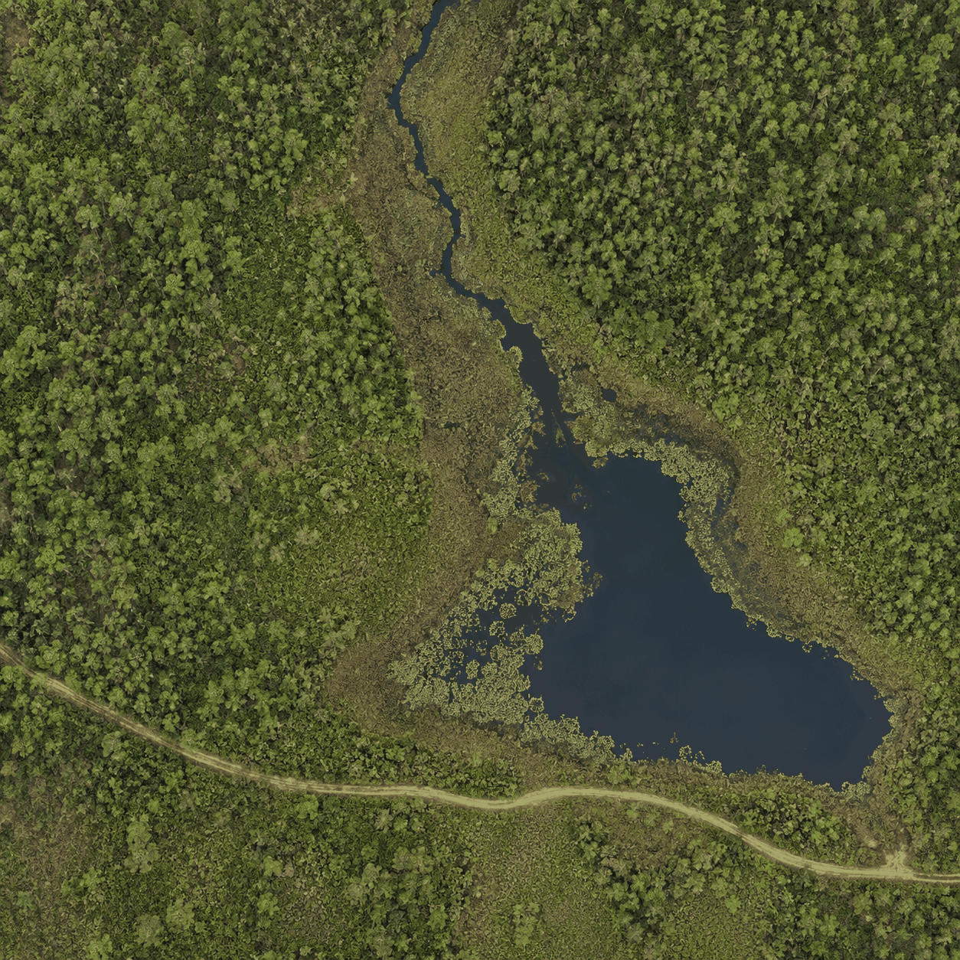 | NDVI surface  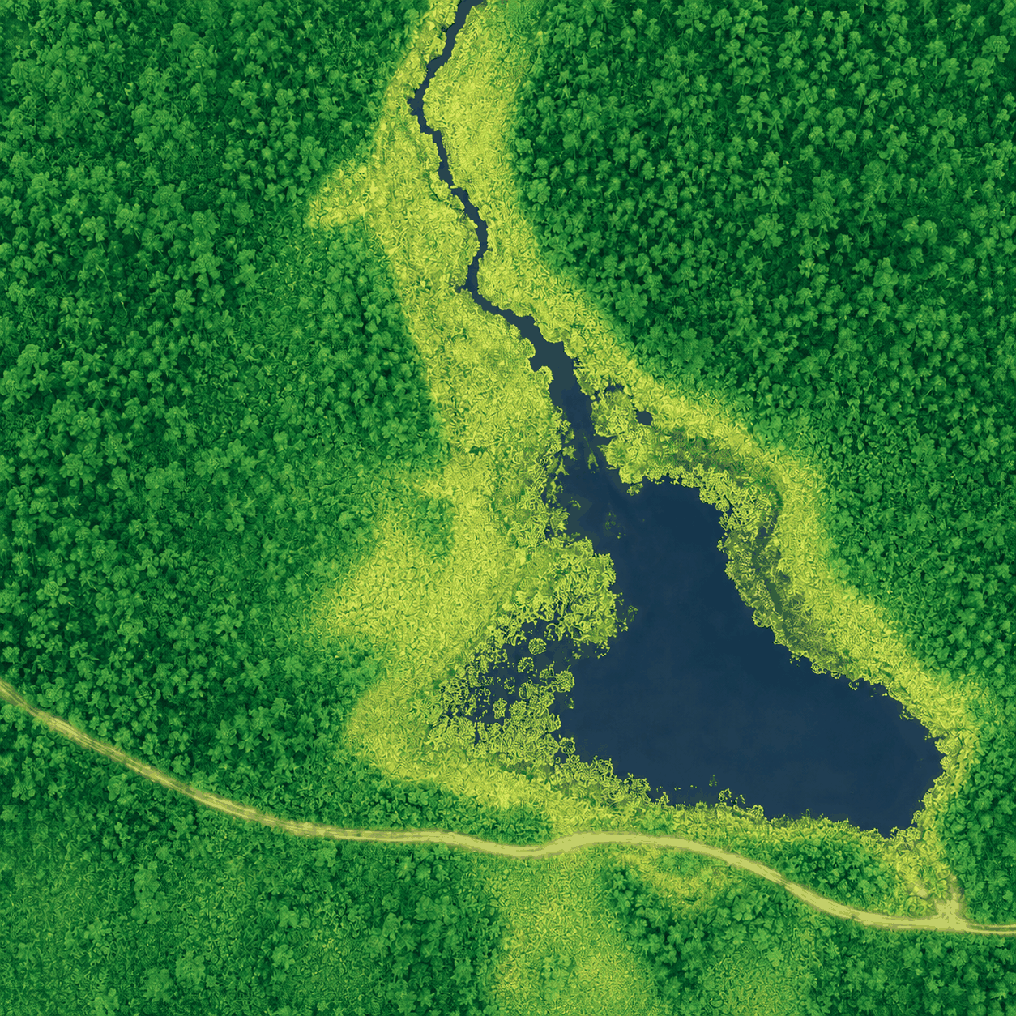
Figure 1. Simulated 400 m x 400 m Marshview Wetland learning site. Students should use the same zone boundaries and sample identifiers in both views.

Zone interpretation key
Zone | Mapped cover | Mean NDVI | Expected interpretation
A | Dense upland/emergent vegetation | 0.67 on web summary; samples 0.50-0.53 | High positive vegetation signal; reference for dense cover.
B | Patchy wetland edge | 0.31 on web summary; samples 0.19-0.34 | Primary inspection target; low positive signal plus visible patchiness.
C | Open water and sparse floating vegetation | -0.08 on web summary; samples -0.27 to -0.07 | Low/negative values are consistent with water, not a stress ranking.
D | Mixed reference vegetation | 0.46 on web summary; samples 0.43-0.48 | Moderate positive signal without visible discoloration.
Important distinction
The web activity displays rounded zone summaries for quick comparison. The CSV contains individual field-sample values. Students may cite either source if they label it correctly; stronger projects use the individual samples to describe within-zone variation.

PART 3 · COMPLETED QUANTITATIVE ANALYSIS

Sample-level answer key
Sample | Zone | Red | NIR | NDVI | Depth cm | Field note
S1 | A | .18 | .58 | .50 | 22 | Dense emergent vegetation
S2 | A | .20 | .62 | .51 | 18 | Dense emergent vegetation
S3 | A | .17 | .55 | .53 | 25 | No visible discoloration
S4 | B | .25 | .51 | .34 | 9 | Patchy vegetation
S5 | B | .29 | .49 | .26 | 7 | Yellow-brown leaves
S6 | B | .31 | .46 | .19 | 5 | Bare soil between stems
S7 | C | .14 | .08 | -.27 | 61 | Open water
S8 | C | .12 | .10 | -.09 | 54 | Sparse floating vegetation
S9 | C | .15 | .13 | -.07 | 48 | Open-water edge
S10 | D | .21 | .60 | .48 | 15 | Mixed wetland vegetation
S11 | D | .23 | .57 | .43 | 13 | Mixed wetland vegetation
S12 | D | .20 | .55 | .47 | 17 | No visible discoloration

Expected calculations and comparisons
- Example: S6 NDVI = (0.46 - 0.31) / (0.46 + 0.31) = 0.15 / 0.77 = 0.19.
- Zone B sample mean = (0.34 + 0.26 + 0.19) / 3 = 0.26.
- Zone A sample mean = 0.51; Zone D sample mean = 0.46. Zone B is about 0.25 below Zone A and 0.20 below Zone D.
- Zone B also becomes progressively lower from S4 to S6 while water depth declines from 9 cm to 5 cm. This is a useful association to test, not proof that shallow water caused the pattern.
- Zone C's mean is approximately -0.14, but it represents open water and should not be compared as if it were a vegetated reference zone.

PART 4 · COMPLETED CAPSTONE MODEL

Marshview Wetland vegetation-stress investigation

Executive summary
The mapped evidence supports Zone B as the first location for targeted ground investigation. Zone B combines lower positive NDVI values, visible patchiness, shallow-water measurements, yellow-brown leaves, and exposed soil. Zones A and D provide stronger vegetated reference conditions. Zone C has lower NDVI values, but it is open water. The imagery does not establish a cause, so the recommended action is a focused field survey and repeat imagery before any treatment or restoration decision.

Focused research question
Model question
Where does the Marshview imagery show an anomalous vegetation signal, and what field observations are needed to distinguish hydrologic stress from other explanations?

Sensor and flight-design explanation
The demonstration uses a DJI Mavic 3 Multispectral at 200 ft AGL (61 m) on a nadir mapping grid. The RGB camera records visible red, green, and blue reflectance for natural-color interpretation. The multispectral system records narrow spectral bands, including red and near-infrared, used to calculate NDVI. Overlapping images are processed into aligned orthomosaics so patterns can be compared spatially. Consistent illumination, radiometric calibration, positional accuracy, overlap, focus, and timing affect the reliability of the products.

Methods
- Compare the natural-color orthomosaic and NDVI surface using identical zone boundaries.
- Review individual red, NIR, NDVI, water-depth, and field-note values for S1-S12.
- Compare Zone B with vegetated reference Zones A and D; use Zone C to explain the water response.
- Identify alternative explanations and design field observations that could discriminate among them.

Results
Zone B contains the clearest anomalous vegetation pattern. Its samples range from 0.19 to 0.34 NDVI (mean 0.26), compared with 0.50-0.53 in Zone A (mean 0.51) and 0.43-0.48 in Zone D (mean 0.46). Field notes describe patchy vegetation at S4, yellow-brown leaves at S5, and bare soil between stems at S6. Measured water depth decreases from 9 cm to 5 cm across those samples. Zone C values range from -0.27 to -0.07 and correspond to open water or sparse floating vegetation.

PART 4 · COMPLETED CAPSTONE MODEL, CONTINUED

Claim, evidence, and reasoning
Claim | Zone B should receive the first targeted ground inspection for possible vegetation stress.
Evidence | Zone B has substantially lower positive NDVI than vegetated references, a visible patchy pattern, stress-related field notes, and shallow-water measurements.
Reasoning | The agreement between spectral, visual, and field-note evidence makes Zone B anomalous among vegetated zones. Zone C's lower values reflect a different land-cover class - water - so they do not indicate a stronger vegetation-stress priority.

Alternative explanations and uncertainty
- Hydrology: lower water depth or altered hydroperiod may affect vegetation cover and reflectance.
- Species composition or phenology: different plants or seasonal stages may have different spectral responses without being unhealthy.
- Salinity, soil exposure, nutrient status, pests, disease, mowing, trampling, or recent disturbance could produce similar patterns.
- Calibration, shadows, illumination changes, mixed pixels, image seams, or positional mismatch could affect the mapped values.
Confidence is moderate that Zone B is the correct inspection priority, but low that any specific cause has been identified.

Targeted field-check plan
Where | Measure or observe | Purpose
S4-S6 and two additional Zone B transects | Species, percent cover, leaf discoloration, canopy height, soil exposure | Confirm whether the image pattern represents sparse or discolored vegetation.
Matched plots in A and D | Same vegetation and soil observations | Provide reference conditions for comparison.
All plots | Water depth, soil moisture, salinity/conductivity, recent disturbance | Test hydrologic and soil-related explanations.
Repeat flight | Same altitude, timing, calibration, and processing | Determine whether the pattern persists and reduce acquisition-related uncertainty.

PART 4 · COMPLETED CAPSTONE MODEL, CONCLUSION

Evidence-proportionate recommendation
Recommended action
Inspect Zone B first using stratified field plots and matched reference plots in Zones A and D. Repeat the imagery under comparable conditions. Do not prescribe treatment, drainage changes, or restoration until field measurements distinguish among hydrologic, biological, disturbance, and data-quality explanations.

Model conclusion
Drone remote sensing efficiently narrows the area that requires closer inspection, but it does not replace ecological field measurements. In this case, the combined map and sample evidence identifies Zone B as an appropriate first priority. The responsible management decision is therefore to collect targeted ground evidence and repeat observations before acting on an unconfirmed diagnosis.

Suggested figure and table set
- Figure 1. Natural-color orthomosaic with Zones A-D and sample points S1-S12.
- Figure 2. NDVI surface with the same boundaries, sample points, legend, north arrow, and scale.
- Table 1. Sample-level Red, NIR, NDVI, water depth, and field observations.
- Table 2. Zone comparison summarizing land cover, NDVI pattern, uncertainty, and next field check.

Source and figure attribution
Use: 'Marshview Wetland simulated instructional dataset and imagery, Michael S. Baird GIS Portfolio.' Students should also cite any external scientific sources used to explain NDVI, wetland ecology, or sampling methods.
Scientific boundary
A strong completed project identifies a priority for investigation. It does not claim that NDVI proves vegetation health, species identity, disease, nutrient deficiency, or a specific management cause.

PART 5 · SCORING CROSSWALK

How the model meets the capstone rubric
Rubric criterion | Model evidence | Full-credit look-for
Problem and question | Decision-focused question about anomaly and field verification | Specific, measurable, and tied to a management decision
Sensor/data logic | Explains RGB, multispectral bands, NDVI, and orthomosaics | Separates measurement, product, and inference
Data analysis | Integrates maps, sample values, and field notes | Uses relevant comparisons accurately
Environmental interpretation | Identifies Zone B while rejecting water as a stress ranking | Calibrated inference with alternatives
Quantitative support | Computes means, ranges, and contrasts | Accurate values with meaningful interpretation
Limitations/uncertainty | Names ecological and acquisition uncertainties | Links uncertainty to confidence and decisions
Additional data | Stratified plots, matched references, repeat imagery | Measurements discriminate among explanations
Recommendation | Inspect and verify before treatment | Feasible and proportional to evidence
Communication | Clear headings, figures, tables, units, attribution | Accessible, organized, and source-aware

Fast instructor checklist
- ☐ Zone B selected and compared with A and D
- ☐ Zone C correctly interpreted as open water
- ☐ At least one valid calculation or quantitative contrast
- ☐ Cause stated as uncertain rather than proven
- ☐ Specific field data proposed to test alternatives
- ☐ Recommendation limited to inspection, validation, and repeat observation
- ☐ Maps, tables, units, labels, and sources are clear
Scoring note
Accept scientifically equivalent answers when the evidence, reasoning, and uncertainty are sound. Reduce credit for unsupported causal claims even when the correct priority zone is selected.

