EDUCATION PORTFOLIO IMPLEMENTATION

Introduction to Drone Remote Sensing for Environmental Science
  - Landing-Page Copy, Download Structure, and 'Try the Investigation' Concept
AUDIENCE  Hiring reviewers, instructors, and prospective collaborators | LENGTH  10 instructional days | RESOURCE  Portfolio presentation - draft only

Driving question: How can drone-based remote sensing help environmental scientists observe, measure, and manage environmental change?

Publication boundary This package supplies structure and copy only. It does not modify or publish the portfolio.

Education landing-page structure
Section | Purpose | Recommended content
Hero / overview | Establish value in seconds | Title, two-sentence summary, audience, duration, View Materials and Try the Investigation actions
Why this unit | Show instructional-design judgment | Remote sensing as environmental measurement; no drone flight required; inquiry and evidence focus
What students learn | Make outcomes scannable | Sensors, resolution, NDVI, photogrammetry, uncertainty, responsible decisions
10-day pathway | Show coherent sequencing | Compact timeline from image interpretation to scientific briefing
Try the Investigation | Demonstrate learning experience | Layer/view toggles, sample table, prompt, response scaffold, revealable reasoning
Assessment design | Show rigor and inclusion | Formative checks, capstone, individual assessment, analytic rubric
Downloads | Give practical access | Instructor Guide, Student Workbook, Assessment/Key, simulated data, two map images
Design notes | Show professional reflection | Audience, accessibility, adaptation, evidence limits, source currency

Portfolio card copy
Card title Introduction to Drone Remote Sensing

A 10-day inquiry-based environmental science unit in which students interpret aerial and multispectral evidence, calculate NDVI, evaluate uncertainty, and deliver an evidence-based wetland management briefing. Designed for AP Environmental Science and introductory undergraduate learners; no drone operation is required.
Suggested tags: Instructional Design | Environmental Science | GIS | Remote Sensing | Assessment

Project-page hero copy

Introduction to Drone Remote Sensing for Environmental Science
A portfolio-ready, 10-day learning unit that moves students from noticing patterns in aerial imagery to defending a calibrated environmental recommendation with spatial and quantitative evidence.
- Audience: AP Environmental Science and introductory undergraduate environmental science
- Format: 10 class meetings, approximately 50-75 minutes each
- Culminating experience: Marshview Wetland remote-sensing assessment
- Technology boundary: fully teachable without operating a drone

Suggested 10-day timeline copy
Day | Student experience
1 | Seeing the Environment from Above
2 | A Drone as a Scientific Measurement System
3 | Sensors and the Electromagnetic Spectrum
4 | Resolution and Scale
5 | Multispectral Data and NDVI
6 | From Photographs to Maps
7 | Environmental Applications Case-Study Stations
8 | Accuracy, Ethics, Safety, and Regulation
9 | Capstone Investigation: Analyze the Evidence
10 | Scientific Briefing and Individual Assessment

Download library
Visitor-facing label | File | Access note
Instructor Guide | 01_instructor_guide_drone_remote_sensing.docx | Planning, pacing, standards, facilitation, differentiation
Student Workbook | 02_student_workbook_drone_remote_sensing.docx | Activities, references, capstone maps, response spaces
Assessment + Answer Key | 03_assessment_answer_key_and_rubric.docx | Label Instructor Resource; avoid placing beside student-only links without a note
Portfolio Presentation Kit | 04_portfolio_landing_page_and_interactive_concept.docx | Page copy and implementation concept
Sample data | simulated_wetland_sample_data.csv | Clearly label simulated instructional data
Natural-color orthomosaic | simulated_wetland_rgb_map.png | Alt text supplied below
NDVI map | simulated_wetland_ndvi_map.png | Use a labeled legend and text alternative

'Try the Investigation' interactive concept
Visitor prompt Which zone should environmental scientists investigate first, and what evidence supports your conclusion?

Recommended interaction flow
- 1. Orient: read a 60-word client brief and view the study-area zones.
- 2. Inspect: toggle between the natural-color orthomosaic and NDVI views; open sample-point details. The demonstration flight context is a DJI Mavic 3 Multispectral at 200 ft AGL (61 m).
- 3. Reason: select a priority zone and choose or type two pieces of evidence.
- 4. Qualify: choose one limitation or alternative explanation.
- 5. Recommend: select a proportional next step.
- 6. Compare: reveal an instructor model only after the visitor submits a response.

Screen-level content
Panel | Content / behavior
Client brief | Staff observed discoloration in emergent vegetation; prioritize follow-up, not treatment.
Map | Side-by-side on wide screens; tabs on small screens. Keep Zone labels visible in both views.
Sample drawer | Rows S1-S12 with Red, NIR, provided NDVI, water depth, and field note.
Response | Priority Zone A/B/C/D; evidence chips plus optional text; uncertainty; next step.
Feedback | Explain that Zone B is best supported; warn that Zone C is water; emphasize causal uncertainty.
Extension | Optional calculate-NDVI mode hides provided values for three samples.

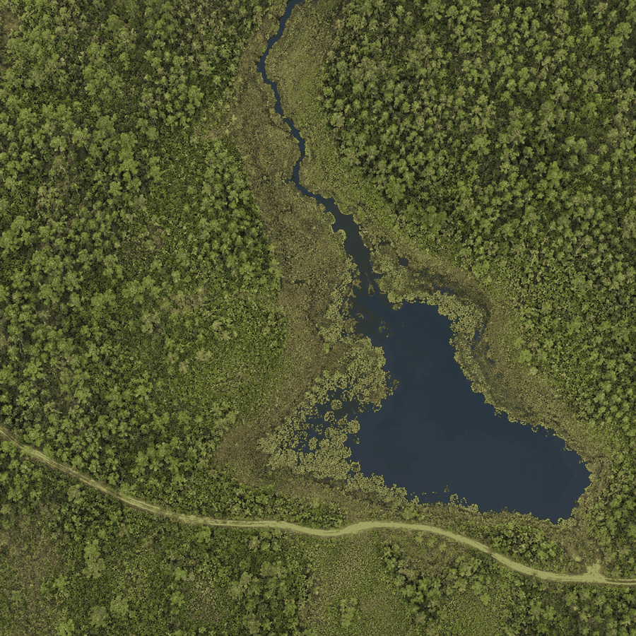
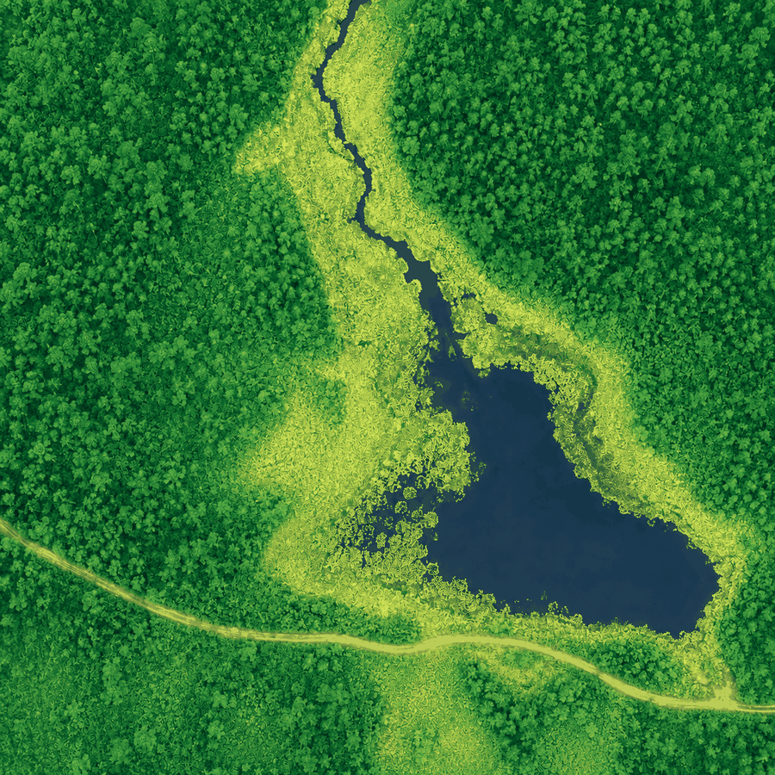

Model feedback after submission
Zone B is the strongest priority because its three samples combine lower positive NDVI with field notes describing patchy or discolored vegetation. Zone C has lower values, but it is open water; negative NDVI there does not identify stressed emergent vegetation. The appropriate next step is targeted field sampling and repeat/controlled measurement, not immediate treatment.

Accessibility requirements
- Keyboard-operable layer tabs, sample points, form controls, and feedback reveal.
- Do not encode meaning by color alone; retain zone labels, point labels, and a table alternative.
- High-contrast focus states and text with at least WCAG AA contrast.
- Map alt text: 'Simulated natural-color drone orthomosaic of a wetland divided into Zones A-D. A creek, open-water pond, maintenance track, and field sample locations orient the investigation.'
- NDVI alt text: 'Simulated NDVI orthomosaic of the same wetland, with stronger vegetation response in Zones A and D, moderately lower response in Zone B, and lowest values over open-water Zone C.'
- A complete non-map pathway using the sample table and zone summaries.
- No timer; feedback does not rely on animation; downloadable files use descriptive names.

Suggested real-world datasets and visuals
Resource | Best use | Implementation caution
OpenAerialMap | Openly licensed aerial/UAV imagery for image interpretation | Coverage and dates vary; verify the specific image license and metadata.
USGS EarthExplorer / Landsat | Regional comparison, multitemporal context, NDVI extension | 30 m pixels illustrate scale differences but are not drone imagery.
USDA NAIP via EarthExplorer or GIS services | US aerial context and land-cover comparison | Imagery date, resolution, and access services vary by location.
Local instructor-owned orthomosaic | Authentic drone workflow demonstration | Remove sensitive locations/people; document permission, accuracy, and processing.
Simulated Marshview packet | Stable portfolio demo with known answer logic | Always label it simulated; do not imply field collection or ecological diagnosis.
Workflow and product screenshots | Show overlap, point cloud, orthomosaic, and surface model | Use only original, licensed, or properly attributed visuals.

Editorial and implementation notes
- Keep the project inside the existing Education section and visual system; avoid redesigning unrelated portfolio routes.
- Lead with the student experience, then show the design rationale and standards.
- Preview workbook pages and the interactive evidence task; do not place full answer keys in a student-facing preview.
- Label all simulated data and generated visuals at the point of use.
- Add a 'last reviewed' date near standards and FAA links.
- Offer DOCX downloads for instructor adaptation; optionally export accessible PDFs before publication.
- Do not publish until the owner reviews copy, file visibility, answer-key placement, and mobile/accessibility behavior.

Sources and currency note
Standards and flight rules can change. The references below were checked on September 1, 2026. Instructors should recheck FAA and local requirements before any real-world flight. This unit does not require students to operate a drone.
- College Board, AP Environmental Science
- Next Generation Science Standards, HS-ESS3-4
- Next Generation Science Standards, HS-ESS3-6
- Next Generation Science Standards, HS-LS2-7
- FAA, Recreational Flyers and Small UAS overview
- USGS, Landsat Data Access
- OpenAerialMap

