INQUIRY WORKBOOK

Introduction to Drone Remote Sensing for Environmental Science
  - Student Workbook and Capstone Data Packet
AUDIENCE  AP Environmental Science and introductory undergraduate environmental science | LENGTH  10 instructional days | RESOURCE  Student-facing activities

Driving question: How can drone-based remote sensing help environmental scientists observe, measure, and manage environmental change?

How to use this workbook
This unit treats remote sensing as a measurement and reasoning process. You will repeatedly separate what a sensor records from what an environmental scientist infers. You do not need to operate a drone or use specialized software.
Evidence habit Use the sequence Observe -> Quantify -> Interpret -> Question uncertainty -> Recommend a next step.

Unit vocabulary and quick reference
Term | Working definition
Remote sensing | Obtaining information about an object or area without direct physical contact, using recorded electromagnetic energy or ranging.
sUAS | Small uncrewed aircraft system: aircraft plus control, communication, payload, and supporting components.
Passive sensor | Records naturally reflected or emitted energy; examples include RGB, multispectral, and thermal cameras.
Active sensor | Emits energy and measures its return; lidar is a common example.
Reflectance | Proportion of incoming energy reflected by a surface at a wavelength.
Spectral band | A defined wavelength interval recorded by a sensor.
RGB | Red, green, and blue visible-light bands used for natural-color imagery.
Multispectral | Several discrete bands, often including wavelengths beyond human vision.
Thermal infrared | Emitted energy associated with surface temperature; apparent temperature requires careful calibration and context.
Lidar | Active laser ranging used to estimate distance and three-dimensional structure.
Spatial resolution | Ground dimensions represented by a pixel, often called ground sampling distance for drone imagery.
Spectral resolution | How narrowly and how many wavelength regions a sensor distinguishes.
Temporal resolution | How often the same location can be observed.
Radiometric resolution | Sensitivity to differences in recorded energy intensity.
NDVI | Normalized Difference Vegetation Index: (NIR - Red) / (NIR + Red).
Orthomosaic | A georeferenced, geometrically corrected mosaic made from overlapping images.
Photogrammetry | Deriving measurements and 3D information from overlapping photographs.
Point cloud | A collection of three-dimensional points representing surfaces or objects.
DSM / DTM | A digital surface model includes surface features; a digital terrain model aims to represent bare ground.
Ground control point | A clearly identifiable point with surveyed coordinates used to improve or evaluate positioning.
Validation | Independent observations used to test whether a remote interpretation is accurate.
Uncertainty | A quantified or described limit on confidence arising from measurement, sampling, processing, or interpretation.

Sensor selection reference
Sensor | Directly records | Useful for | Watch for
RGB | Visible reflected light | Land cover, erosion, visible damage, mapping | Lighting, shadows, color balance
Multispectral | Selected reflected bands | Vegetation indices, water/soil contrasts | Calibration, species/season effects
Thermal | Emitted infrared energy | Surface-temperature patterns, leaks, water stress | Time of day, emissivity, weather
Lidar | Laser travel time/range | Elevation and vegetation structure | Cost, density, classification

NDVI calculation frame
NDVI = (NIR - Red) / (NIR + Red)
- Check that NIR and Red use comparable reflectance units.
- Calculate the numerator and denominator separately.
- Values commonly range from -1 to +1.
- Interpret patterns in ecological context; NDVI is not a diagnosis.

Day 1: Seeing the Environment from Above
Essential question What can an aerial view reveal that a ground-level view may miss?

Name: ______________________________ Date: __________________
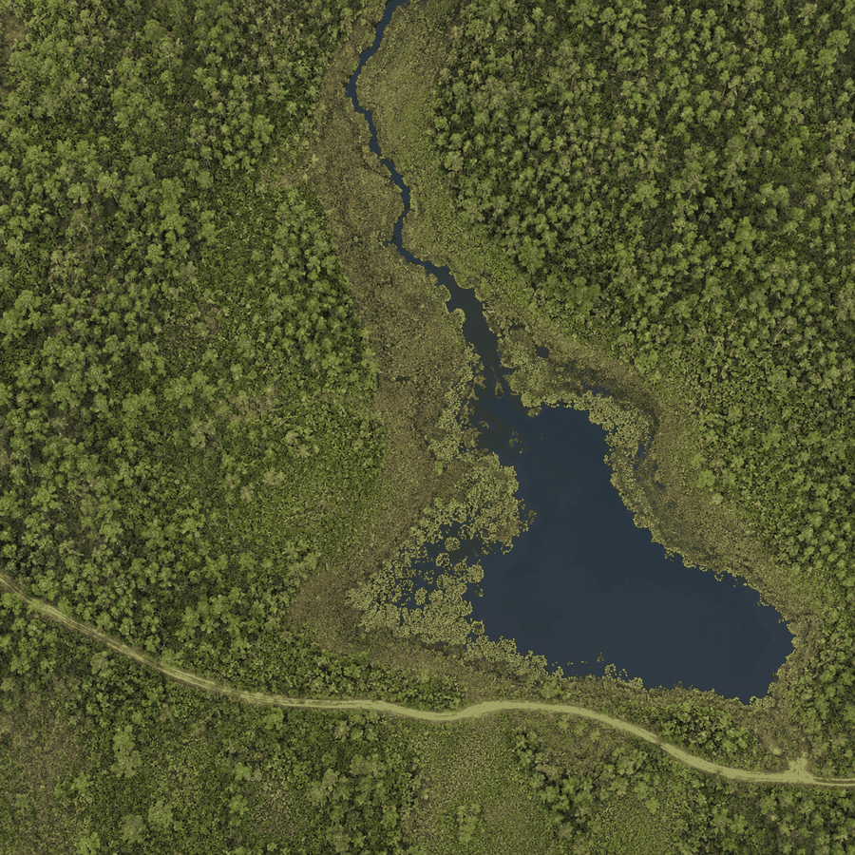

Activity 1A - Notice, then interpret
Neutral observation | Possible interpretation | Evidence needed to test it

Which pattern is easiest to see from above? Why?
________________________________________________________________________________
________________________________________________________________________________
________________________________________________________________________________
Exit ticket: Name one phenomenon suited to remote observation, one advantage, and one needed ground check.
________________________________________________________________________________
________________________________________________________________________________
________________________________________________________________________________

Day 2: A Drone as a Scientific Measurement System
Essential question How does a drone become more than a flying camera?

Name: ______________________________ Date: __________________
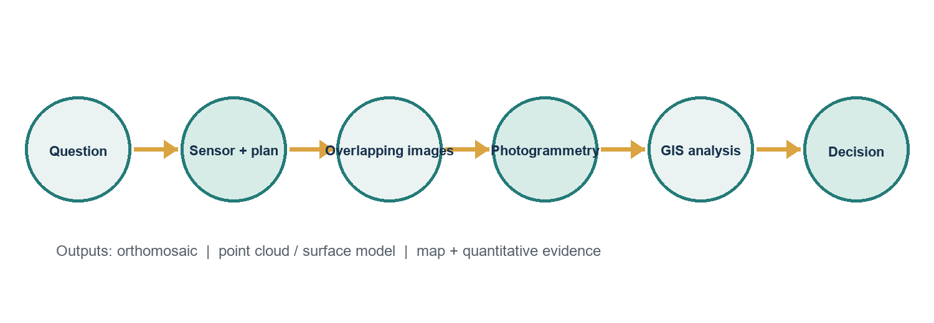

Activity 2A - Build a defensible mission
Scenario: A manager suspects that an invasive wetland plant has expanded across a 40-hectare preserve. Complete the workflow.
Environmental decision and research question
________________________________________________________________________________
Sensor and the physical measurement it records
________________________________________________________________________________
Flight/coverage information needed
________________________________________________________________________________
Ground observations needed
________________________________________________________________________________
Processing output
________________________________________________________________________________
Quality-control checks
________________________________________________________________________________
Evidence that would support or challenge the interpretation
________________________________________________________________________________

Day 3: Sensors and the Electromagnetic Spectrum
Essential question Which sensor can answer which environmental question?

Name: ______________________________ Date: __________________

Activity 3A - Choose the sensor
Mission | Best starting sensor | Measurement-based justification
Detect crop stress before strong visible symptoms
Locate unusually warm water entering a stream
Map detailed canopy height and terrain structure
Document visible shoreline change after a storm

Select one mission. What would the sensor record directly, and what would you infer?
________________________________________________________________________________
________________________________________________________________________________
________________________________________________________________________________

Day 4: Resolution and Scale
Essential question How much detail is enough to answer the question?

Name: ______________________________ Date: __________________

Activity 4A - Resolution laboratory
Feature | Approx. width | 2 cm pixels | 10 cm | 1 m | 10 m | 30 m
Single leaf | 8 cm
Young tree crown | 2 m
Wetland patch | 25 m
Forest stand | 300 m

For each cell, mark D (likely detectable), U (uncertain), or N (not reliably detectable). Then explain two choices.
Why might the finest resolution not be the best operational choice?
________________________________________________________________________________
________________________________________________________________________________
________________________________________________________________________________
Exit ticket: Explain the 30 m forest / individual-tree contrast.
________________________________________________________________________________
________________________________________________________________________________
________________________________________________________________________________

Day 5: Multispectral Data and NDVI
Essential question How can red and near-infrared reflectance reveal vegetation patterns?

Name: ______________________________ Date: __________________

Activity 5A - Calculate and interpret NDVI
Point | Red | NIR | NDVI | Careful interpretation
P1 | 0.2 | 0.6
P2 | 0.3 | 0.45
P3 | 0.12 | 0.1
P4 | 0.18 | 0.54
P5 | 0.28 | 0.36

Write one defensible interpretation and one overclaim for P1.
________________________________________________________________________________
________________________________________________________________________________
________________________________________________________________________________
List two non-health factors that can influence NDVI.
________________________________________________________________________________
________________________________________________________________________________

Day 6: From Photographs to Maps
Essential question Why are overlapping photographs not yet a reliable map?

Name: ______________________________ Date: __________________

Activity 6A - Product and process match
Number these steps from 1 to 7: ____ collect overlapping photographs ____ environmental interpretation ____ identify research question ____ feature matching and camera estimation ____ build point cloud ____ produce orthomosaic/model ____ verify position and quality
Product | What it represents | One limitation
Individual photograph
Orthomosaic
Point cloud
Digital surface model
Digital terrain model

Why can a surface model differ from bare-earth elevation?
________________________________________________________________________________
________________________________________________________________________________
________________________________________________________________________________

Day 7: Environmental Applications Case-Study Stations
Essential question How does the environmental question shape the sensing strategy?

Name: ______________________________ Date: __________________

Precision agriculture
A grower sees uneven crop vigor before harvest.
Question | Team response
Sensor and why
Fit-for-purpose resolution
Useful remote product
Ground data
Important limitation

Wetland monitoring
A preserve needs to map invasive vegetation and open water.
Question | Team response
Sensor and why
Fit-for-purpose resolution
Useful remote product
Ground data
Important limitation

Coastal erosion
A manager needs post-storm shoreline and dune-change evidence.
Question | Team response
Sensor and why
Fit-for-purpose resolution
Useful remote product
Ground data
Important limitation

Forest management
A forester needs canopy-gap and storm-damage information.
Question | Team response
Sensor and why
Fit-for-purpose resolution
Useful remote product
Ground data
Important limitation

Day 8: Accuracy, Ethics, Safety, and Regulation
Essential question When is a technically possible drone investigation scientifically and socially responsible?

Name: ______________________________ Date: __________________

Activity 8A - Error and responsibility audit
Scenario | Scientific / safety / ethical issue | Responsible response
Deep shadows cross half the vegetation plot
Nesting birds flush when the aircraft approaches
Imagery includes neighboring backyards
Coordinates are shifted several meters
A team wants to fly near controlled airspace

Claim-Evidence-Reasoning
Prompt: Drone remote sensing should replace most ground-based environmental monitoring.
Claim
________________________________________________________________________________
________________________________________________________________________________
Evidence
________________________________________________________________________________
________________________________________________________________________________
________________________________________________________________________________
Reasoning and qualification
________________________________________________________________________________
________________________________________________________________________________
________________________________________________________________________________
________________________________________________________________________________

Day 9: Capstone Investigation: Analyze the Evidence
Essential question Which part of Marshview Wetland should be investigated first, and why?

Name: ______________________________ Date: __________________

Client brief
Marshview Wetland Preserve staff observed patches of discoloration in emergent vegetation. Your consulting team must identify the zone that warrants priority ground investigation. Use the simulated natural-color orthomosaic, NDVI surface, and sample table from a DJI Mavic 3 Multispectral demonstration mission flown at 200 ft AGL (61 m). State what the evidence does not establish.
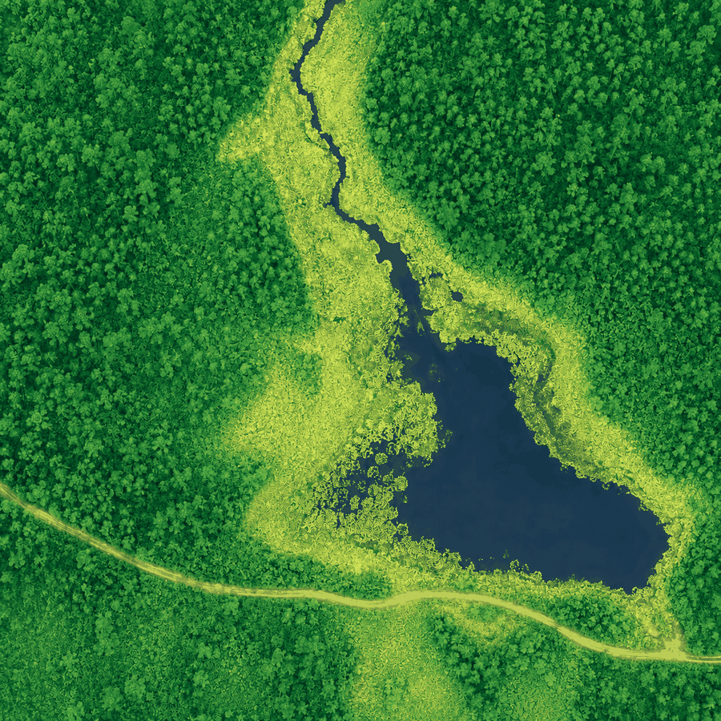

Sample observations
ID | Zone | Red | NIR | NDVI | Depth cm | Field note
S1 | A | 0.18 | 0.58 | 0.5 | 22 | Dense emergent vegetation
S2 | A | 0.2 | 0.62 | 0.51 | 18 | Dense emergent vegetation
S3 | A | 0.17 | 0.55 | 0.53 | 25 | No visible discoloration
S4 | B | 0.25 | 0.51 | 0.34 | 9 | Patchy vegetation
S5 | B | 0.29 | 0.49 | 0.26 | 7 | Yellow-brown leaves
S6 | B | 0.31 | 0.46 | 0.19 | 5 | Bare soil between stems
S7 | C | 0.14 | 0.08 | -0.27 | 61 | Open water
S8 | C | 0.12 | 0.1 | -0.09 | 54 | Floating vegetation sparse
S9 | C | 0.15 | 0.13 | -0.07 | 48 | Open water edge
S10 | D | 0.21 | 0.6 | 0.48 | 15 | Mixed wetland vegetation
S11 | D | 0.23 | 0.57 | 0.43 | 13 | Mixed wetland vegetation
S12 | D | 0.2 | 0.55 | 0.47 | 17 | No visible discoloration

Investigation organizer
Priority zone and claim
________________________________________________________________________________
________________________________________________________________________________
________________________________________________________________________________
Evidence 1: quantitative
________________________________________________________________________________
________________________________________________________________________________
________________________________________________________________________________
Evidence 2: spatial or qualitative
________________________________________________________________________________
________________________________________________________________________________
________________________________________________________________________________
Alternative explanation
________________________________________________________________________________
________________________________________________________________________________
________________________________________________________________________________
Limitation or uncertainty
________________________________________________________________________________
________________________________________________________________________________
________________________________________________________________________________
Additional data and sampling plan
________________________________________________________________________________
________________________________________________________________________________
________________________________________________________________________________
________________________________________________________________________________
Proportional management recommendation
________________________________________________________________________________
________________________________________________________________________________
________________________________________________________________________________
________________________________________________________________________________

Day 10: Scientific Briefing and Individual Assessment
Essential question How should uncertainty shape an environmental recommendation?

Name: ______________________________ Date: __________________

Briefing outline
- Environmental problem and research question
- Data and sensor logic
- Priority zone
- At least two pieces of evidence, including one quantitative
- Interpretation and alternative explanation
- Limitations and uncertainty
- Additional data
- Management recommendation
Peer feedback - strongest evidence
________________________________________________________________________________
________________________________________________________________________________
Peer feedback - question or challenge
________________________________________________________________________________
________________________________________________________________________________
Revision I will make
________________________________________________________________________________
________________________________________________________________________________
Final reflection: How did uncertainty change your recommendation?
________________________________________________________________________________
________________________________________________________________________________
________________________________________________________________________________
________________________________________________________________________________

Capstone submission checklist
- I separated direct observations from interpretations.
- I included at least one quantitative observation.
- I explained why the priority zone matters.
- I addressed water as a reason for low NDVI in Zone C.
- I named uncertainty and additional data.
- My recommendation is proportional to the evidence.
- Maps/figures have titles and are referenced in my explanation.

