PORTFOLIO-READY INSTRUCTIONAL UNIT

Introduction to Drone Remote Sensing for Environmental Science
  - Instructor Guide
AUDIENCE  AP Environmental Science and introductory undergraduate environmental science | LENGTH  10 instructional days | RESOURCE  Instructor planning and facilitation

Driving question: How can drone-based remote sensing help environmental scientists observe, measure, and manage environmental change?

Unit at a glance
Design promise Students can complete the entire unit without flying a drone. The emphasis is environmental measurement, geospatial reasoning, evidence, uncertainty, and responsible decision-making.

Day | Focus | Primary student evidence
1 | Seeing the Environment from Above | Name one environmental phenomenon suited to remote observation and explain why.
2 | A Drone as a Scientific Measurement System | Put eight workflow cards in order and identify one quality-control check before, during, and after collection.
3 | Sensors and the Electromagnetic Spectrum | For thermal discharge, choose a sensor and explain what it measures directly versus what scientists infer.
4 | Resolution and Scale | Explain why 30 m imagery can support regional forest analysis but not reliable diagnosis of an individual tree.
5 | Multispectral Data and NDVI | Calculate NDVI for Red = 0.
6 | From Photographs to Maps | Explain why a digital surface model may show treetops and buildings rather than ground elevation.
7 | Environmental Applications Case-Study Stations | Choose the case with the greatest uncertainty and identify a field measurement that would reduce it.
8 | Accuracy, Ethics, Safety, and Regulation | CER response to: 'Drone remote sensing should replace most ground-based environmental monitoring.
9 | Capstone Investigation: Analyze the Evidence | Submit a claim naming a priority zone, two pieces of evidence, and one uncertainty.
10 | Scientific Briefing and Individual Assessment | Peer feedback: one evidence strength, one question, and one recommendation for revision.

Standards and competencies

AP Environmental Science science practices
- Practice 1 - Concept Explanation: explain remote-sensing concepts, processes, and models.
- Practice 2 - Visual Representations: analyze aerial imagery, maps, and processing diagrams.
- Practice 4 - Scientific Experiments: evaluate investigation design, sampling, controls, and error.
- Practice 5 - Data Analysis: analyze tables, maps, and quantitative spatial patterns.
- Practice 6 - Mathematical Routines: calculate and interpret NDVI and proportions.
- Practice 7 - Environmental Solutions: propose and justify management actions using evidence and constraints.
- Practice 3 - Text Analysis is addressed through source and scenario evaluation, though it is not the unit's primary emphasis.
Content connections are especially strong in biodiversity, land and water use, aquatic and terrestrial pollution, ecosystem change, and environmental solutions. This unit supplements - rather than replaces - required AP investigations and course content.

NGSS alignment
Performance expectation | Unit evidence
HS-ESS3-4 | Students evaluate a monitoring technology and refine a management response while considering evidence, constraints, and trade-offs.
HS-ESS3-6 | Students use mapped and quantitative representations to support claims about interactions among water, vegetation, and human management.
HS-LS2-7 | Students propose and evaluate a solution that reduces impacts on ecosystems or biodiversity.

Introductory undergraduate competencies
- Remote-sensing measurement literacy
- Sensor and scale selection
- Geospatial data interpretation
- Quantitative index calculation
- Sampling and validation design
- Uncertainty and ethics
- Scientific and technical communication

Unit learning objectives
- Define remote sensing and distinguish remote observations from direct field measurements.
- Explain an sUAS environmental data workflow from question through decision.
- Differentiate RGB, multispectral, thermal, and lidar sensors by what they measure.
- Explain spatial, spectral, temporal, and radiometric resolution and their trade-offs.
- Calculate NDVI and interpret it within ecological context.
- Distinguish photographs, orthomosaics, point clouds, surface models, and terrain models.
- Compare drone, satellite, crewed-aircraft, and field approaches.
- Analyze imagery and field observations to develop an evidence-based environmental recommendation.
- Evaluate uncertainty, accuracy, privacy, wildlife, safety, and regulatory considerations.
- Communicate a calibrated claim using maps, quantitative evidence, limitations, and next steps.

Assessment system
Daily low-stakes evidence supports feedback and reteaching. The recommended summative model is 70% capstone investigation and 30% individual concept assessment. Teachers may adjust weighting while retaining separate team and individual evidence.
Evidence | Purpose | Scoring
Daily workbook and exit checks | Find misconceptions early; inform next-day instruction | Completion plus targeted feedback
Capstone environmental assessment | Integrate sensor choice, data analysis, uncertainty, and recommendation | 100-point analytic rubric; suggested 70%
Individual concept assessment | Confirm independent conceptual and quantitative mastery | 30 points; suggested 30%

Materials and technology
- Required: printed or digital Student Workbook, calculator, maps, sample table, and presentation/display access.
- Optional: GIS viewer, spreadsheet, drone hardware for an instructor-led show-and-tell, sample point cloud, or local imagery.
- Not required: drone flight, FAA certification, paid processing software, student accounts, or personally identifiable geolocation data.
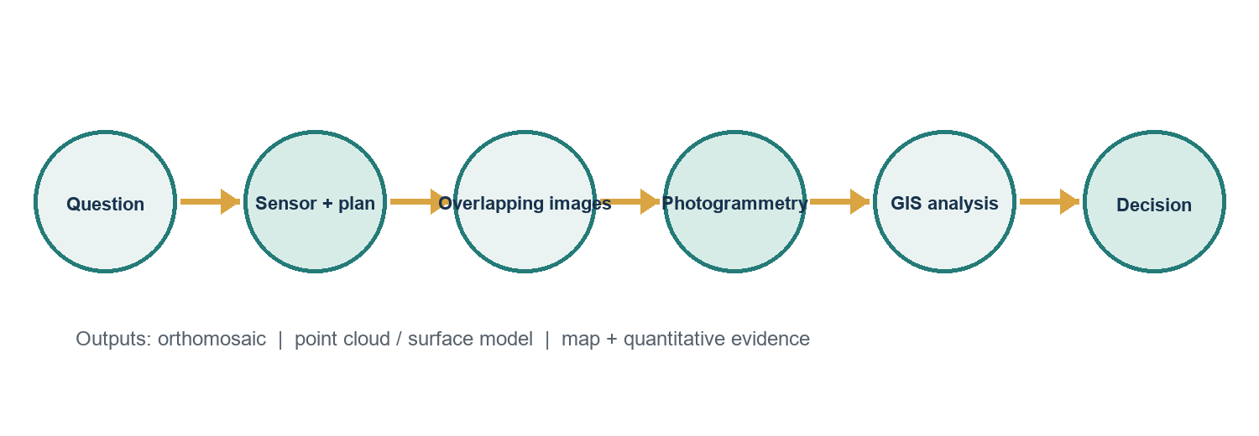
Figure 1. Environmental drone remote-sensing workflow. Products are selected and interpreted in response to a scientific question.

Day 1: Seeing the Environment from Above
Essential question What can an aerial view reveal that a ground-level view may miss?

Measurable objectives
- Distinguish direct field measurement from remote sensing.
- Separate observation from interpretation in aerial imagery.
- Explain one advantage and one limitation of observing environmental systems from above.

Preparation and materials
Student Workbook Day 1; two aerial images or the simulated natural-color orthomosaic; projector or printed copies; sticky notes.

Suggested 60-minute sequence
Minutes | Learning experience
0-7 | Notice/Wonder image hook
7-20 | Mini-lesson: platforms; passive and active sensing
20-42 | Observation versus interpretation investigation
42-52 | Pair critique using evidence language
52-60 | Exit ticket

Instructor moves
Model a neutral observation first (color, shape, texture, pattern), then an interpretation. Press students to name visible evidence before causes. Do not confirm a single cause from imagery alone.

Formative evidence
Name one environmental phenomenon suited to remote observation and explain why. Success requires a phenomenon, a scale/pattern advantage, and a limitation or needed ground check.

Misconception to surface
An aerial image is not automatically a map and a visible pattern is not proof of its cause.

Access and extension
Offer a high-contrast print and an observation word bank. Allow oral dictation. Extension: compare what a drone, aircraft, and satellite could each observe.

Day 2: A Drone as a Scientific Measurement System
Essential question How does a drone become more than a flying camera?

Measurable objectives
- Identify the aircraft, payload, positioning, planning, processing, and analysis components of an sUAS workflow.
- Sequence a defensible environmental data workflow.
- Match mission requirements to equipment and data needs.

Preparation and materials
Workflow visual; Day 2 mission brief; system-component cards; optional drone or photo for demonstration only.

Suggested 60-minute sequence
Minutes | Learning experience
0-8 | Retrieve Day 1 concepts
8-22 | System anatomy and data chain
22-45 | Wetland invasive-plant mission planning
45-54 | Gallery walk and feedback
54-60 | Workflow check

Instructor moves
Treat GNSS accuracy, sensor calibration, overlap, and ground observations as parts of one measurement system. Ask where error may enter at each step.

Formative evidence
Put eight workflow cards in order and identify one quality-control check before, during, and after collection.

Misconception to surface
Buying a precise sensor does not guarantee accurate environmental conclusions.

Access and extension
Provide a partially completed flowchart. Extension: distinguish standard GNSS from RTK/PPK at a conceptual level.

Day 3: Sensors and the Electromagnetic Spectrum
Essential question Which sensor can answer which environmental question?

Measurable objectives
- Differentiate RGB, multispectral, thermal, and lidar measurements.
- Connect visible, near-infrared, thermal emission, and laser ranging to environmental variables.
- Justify a sensor choice for a stated investigation.

Preparation and materials
Sensor reference sheet; mission cards; spectrum diagram; colored pencils.

Suggested 60-minute sequence
Minutes | Learning experience
0-8 | What can human eyes not measure?
8-25 | Spectrum and sensor mini-lesson
25-47 | Choose-the-sensor mission cards
47-55 | Defend and revise
55-60 | One-sentence justification

Instructor moves
Require the pattern: sensor -> physical measurement -> environmental inference -> limitation. Clarify that lidar is active ranging, while standard RGB and multispectral cameras record reflected light.

Formative evidence
For thermal discharge, choose a sensor and explain what it measures directly versus what scientists infer.

Misconception to surface
Sensors do not directly measure 'plant health'; they measure reflected or emitted energy or distance.

Access and extension
Use color and pattern coding together. Give sentence frames. Extension: compare red-edge and near-infrared bands.

Day 4: Resolution and Scale
Essential question How much detail is enough to answer the question?

Measurable objectives
- Explain spatial, spectral, temporal, and radiometric resolution.
- Predict how pixel size affects feature detection.
- Defend a fit-for-purpose resolution rather than simply choosing the finest available.

Preparation and materials
Resolution grids; feature-size cards; ruler; calculator; optional GIS image pyramid.

Suggested 60-minute sequence
Minutes | Learning experience
0-10 | Pixel mystery
10-24 | Four resolutions mini-lesson
24-45 | Feature detection lab
45-54 | Cost/coverage trade-off
54-60 | Resolution claim

Instructor moves
Use the rule of multiple pixels across a feature for reliable recognition, but emphasize that detection thresholds depend on contrast, shape, and purpose.

Formative evidence
Explain why 30 m imagery can support regional forest analysis but not reliable diagnosis of an individual tree.

Misconception to surface
Higher spatial resolution is not always better; it may increase storage, processing, cost, and privacy risk.

Access and extension
Provide enlarged pixel grids. Extension: calculate approximate pixel counts across features and discuss mixed pixels.

Day 5: Multispectral Data and NDVI
Essential question How can red and near-infrared reflectance reveal vegetation patterns?

Measurable objectives
- Describe why photosynthetically active vegetation commonly absorbs red light and reflects more near-infrared energy.
- Calculate NDVI accurately.
- Interpret an NDVI pattern without treating the index as a diagnosis.

Preparation and materials
NDVI practice table; calculator; simulated NDVI map; formula/reference sheet.

Suggested 60-minute sequence
Minutes | Learning experience
0-8 | Leaf reflectance prediction
8-23 | NDVI model and worked example
23-42 | Calculation practice
42-53 | Map interpretation
53-60 | Error check

Instructor moves
Model order of operations and denominator checks. Ask how water, bare soil, shadows, phenology, species, and calibration can change values.

Formative evidence
Calculate NDVI for Red = 0.20 and NIR = 0.60, then state one defensible and one overreaching interpretation.

Misconception to surface
High NDVI means stronger green vegetation signal in context; it does not automatically mean ecosystem health, biodiversity, or absence of invasive species.

Access and extension
Provide color-coded numerator/denominator templates and a calculator. Extension: compare two dates and discuss normalization.

Day 6: From Photographs to Maps
Essential question Why are overlapping photographs not yet a reliable map?

Measurable objectives
- Sequence the photogrammetry workflow.
- Distinguish an individual photograph, orthomosaic, point cloud, and surface/elevation model.
- Explain the roles of overlap, georeferencing, control, and error checking.

Preparation and materials
Workflow visual; image-overlap strips; product cards; optional orthomosaic and point-cloud screenshots.

Suggested 60-minute sequence
Minutes | Learning experience
0-8 | Photo versus map comparison
8-25 | Photogrammetry walkthrough
25-43 | Workflow sequencing and product match
43-54 | Quality-control failure analysis
54-60 | One-minute explanation

Instructor moves
Keep the processing explanation conceptual: software finds common features, estimates camera geometry, reconstructs a 3D scene, and projects outputs. Avoid implying that all outputs represent bare-earth elevation.

Formative evidence
Explain why a digital surface model may show treetops and buildings rather than ground elevation.

Misconception to surface
An orthomosaic is corrected and georeferenced, but it is still subject to positional and reconstruction error.

Access and extension
Provide numbered workflow cards. Extension: compare a digital surface model with a bare-earth terrain model.

Day 7: Environmental Applications Case-Study Stations
Essential question How does the environmental question shape the sensing strategy?

Measurable objectives
- Compare sUAS applications in agriculture, wetlands, coasts, and forests.
- Select sensors and resolutions for different questions.
- Identify complementary field data and limitations.

Preparation and materials
Four station cards; case-study response matrix; timer; sensor reference.

Suggested 60-minute sequence
Minutes | Learning experience
0-7 | Set station norms
7-43 | Four 9-minute stations
43-53 | Cross-case synthesis
53-60 | Most uncertain case exit ticket

Instructor moves
At every station, ask what the imagery measures, what is inferred, and what ground evidence would challenge the inference.

Formative evidence
Choose the case with the greatest uncertainty and identify a field measurement that would reduce it.

Misconception to surface
A single sensor or index is not universally best across environmental problems.

Access and extension
Assign group roles and allow two deeper stations instead of four. Extension: add costs and regulatory constraints to the recommendation.

Day 8: Accuracy, Ethics, Safety, and Regulation
Essential question When is a technically possible drone investigation scientifically and socially responsible?

Measurable objectives
- Identify environmental, geometric, and procedural sources of uncertainty.
- Evaluate privacy, wildlife, equity, and data-governance concerns.
- Explain why real operations require current rule, airspace, site, and safety checks.

Preparation and materials
Scenario cards; CER organizer; current FAA webpage; local/site policy placeholder.

Suggested 60-minute sequence
Minutes | Learning experience
0-10 | Error-source sort
10-24 | Safety and rule framework
24-44 | Ethics scenarios
44-55 | CER: replace field sampling?
55-60 | Commitment to responsible evidence

Instructor moves
Do not turn this into flight training. Emphasize that Part 107, recreational rules, Remote ID, airspace authorization, site permission, privacy, wildlife, and local requirements must be checked for an actual mission.

Formative evidence
CER response to: 'Drone remote sensing should replace most ground-based environmental monitoring.'

Misconception to surface
Legal permission does not by itself establish ethical, ecologically responsible, or scientifically valid practice.

Access and extension
Provide a CER frame and allow recorded responses. Extension: write a data-governance clause for a community project.

Day 9: Capstone Investigation: Analyze the Evidence
Essential question Which part of Marshview Wetland should be investigated first, and why?

Measurable objectives
- Analyze a simulated natural-color orthomosaic, NDVI surface, and field table from a DJI Mavic 3 Multispectral demonstration mission flown at 200 ft AGL (61 m).
- Use quantitative and qualitative evidence in a defensible claim.
- Identify limitations and propose additional data collection.

Preparation and materials
Capstone packet; maps; sample data; calculator; planning organizer; rubric.

Suggested 60-minute sequence
Minutes | Learning experience
0-8 | Client briefing
8-18 | Individual noticing
18-42 | Team analysis
42-53 | Evidence conference
53-60 | Draft claim and next-data request

Instructor moves
Do not reveal that Zone B is the priority. Use questions: Which values are unlike the reference zones? What alternative explanations remain? Does water explain the pattern?

Formative evidence
Submit a claim naming a priority zone, two pieces of evidence, and one uncertainty.

Misconception to surface
The lowest NDVI is not automatically the most stressed vegetation; open water can have negative NDVI.

Access and extension
Provide precomputed NDVI values while retaining optional calculations. Extension: summarize zone means and propose a stratified field-sampling design.

Day 10: Scientific Briefing and Individual Assessment
Essential question How should uncertainty shape an environmental recommendation?

Measurable objectives
- Communicate an evidence-based environmental assessment.
- Evaluate recommendations using criteria and limitations.
- Demonstrate individual understanding of sensors, resolution, NDVI, photogrammetry, and responsible use.

Preparation and materials
Briefing template; rubric; peer-feedback form; individual assessment.

Suggested 60-minute sequence
Minutes | Learning experience
0-8 | Briefing preparation
8-32 | Team briefings or gallery walk
32-42 | Peer questions and revision note
42-58 | Individual assessment
58-60 | Reflection

Instructor moves
Score the capstone product separately from individual mastery. Reward calibrated claims and explicit uncertainty, not confidence alone.

Formative evidence
Peer feedback: one evidence strength, one question, and one recommendation for revision.

Misconception to surface
A recommendation can be useful without claiming certainty; good decisions state evidence, risk, and next steps.

Access and extension
Offer report, narrated slides, or oral briefing with the same criteria. Provide extended time for the individual assessment when documented.

Capstone facilitation guide
Client scenario: Marshview Wetland Preserve staff observed patches of discoloration in emergent vegetation. Students must determine which zone warrants priority ground investigation, explain what the evidence does and does not show, and recommend a responsible next step.
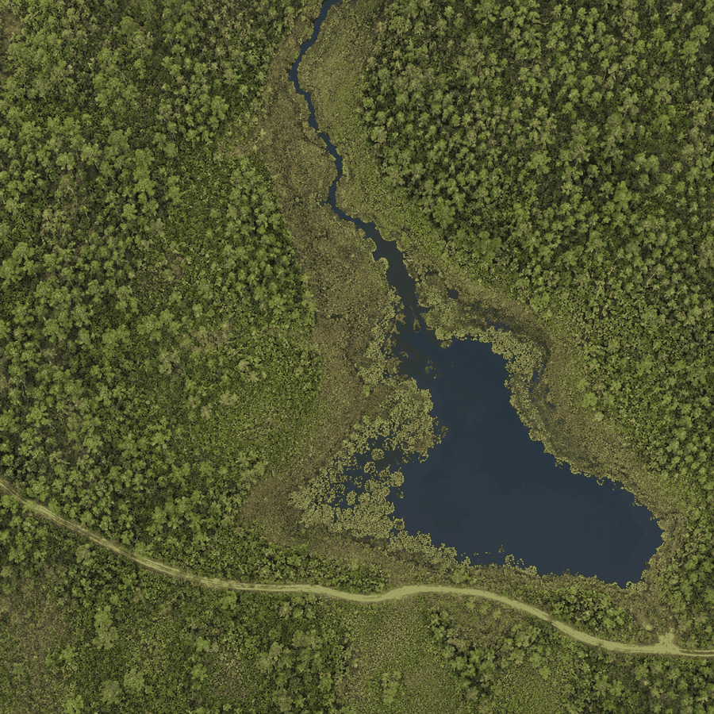
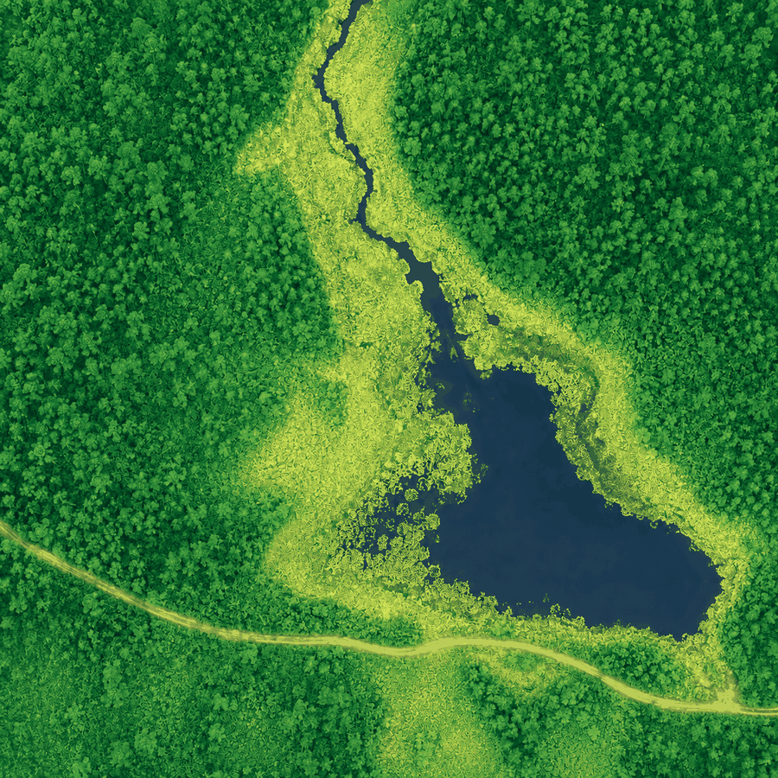
Instructor interpretation Zone B is the defensible priority for vegetation-stress follow-up: its samples have lower positive NDVI (0.19-0.34) and field notes describe patchiness, discoloration, and exposed soil. Zone C has the lowest NDVI but is open water, so it is not evidence of stressed emergent vegetation. The dataset supports prioritization, not a causal diagnosis.

Suggested discussion prompts
- What direct measurements appear in the packet?
- Which conclusions are inferences?
- What alternative explanations fit Zone B?
- What additional measurements would discriminate among causes?
- What management action is proportional to the evidence?

Differentiation and accommodations across the unit
Learner need | Designed support | Preserved learning target
Language development | Visual glossary, sentence frames, partner rehearsal, annotated models | Scientific evidence and reasoning
Mathematical support | Color-coded NDVI template, worked example, calculator, precomputed values | Interpretation and error checking
Visual access | High-contrast maps, pattern/label redundancy, text descriptions, tabular equivalent | Spatial-pattern reasoning
Motor access | No flight required; keyboard-accessible digital or oral response options | Measurement and decision concepts
Attention/executive function | Chunked directions, visible agenda, group roles, checkpoints | Complete investigation workflow
Advanced readiness | Zone summaries, sampling design, uncertainty quantification, multi-date analysis | Deeper analysis without extra busywork

Safety and implementation boundary
Important This curriculum is not flight training and does not authorize drone operation. Any optional real-world flight must be planned and supervised by appropriately qualified personnel under current FAA rules, airspace requirements, site permissions, institutional policy, privacy law, and wildlife guidance.

Sources and currency note
Standards and flight rules can change. The references below were checked on September 1, 2026. Instructors should recheck FAA and local requirements before any real-world flight. This unit does not require students to operate a drone.
- College Board, AP Environmental Science
- Next Generation Science Standards, HS-ESS3-4
- Next Generation Science Standards, HS-ESS3-6
- Next Generation Science Standards, HS-LS2-7
- FAA, Recreational Flyers and Small UAS overview
- USGS, Landsat Data Access
- OpenAerialMap

